FOR IMMEDIATE RELEASE
Kacmarcik Enterprises and Bear Development Unveil Transformative Sports and Entertainment District in Downtown Milwaukee
The development will be home to a professional soccer club, state-of-the-art entertainment venue operated by a premier concert promoter and the Pabst Theater Group, hotel, retail, and dining
Milwaukee, Wisconsin – Kacmarcik Enterprises and Bear Development have agreed to purchase an 11-acre parcel from Marquette University that the companies plan to develop into a vibrant sports and entertainment district.
The parcel, which will be master developed by Kenosha-based Bear Development, is bordered by North Sixth Street to the east, Michigan Street to the north, and the 794/I-43 interchange to the east and south. The space exists in one of the most visible gateways to the City of Milwaukee and the busiest intersection in Wisconsin. Plans for the comprehensive district include the development of a stadium, which will be home to a professional soccer club, an indoor concert venue, a full-service hotel, multi-family residential housing, retail, and food and beverage elements.
The development will catalyze the Westown neighborhood and the region while playing a pivotal role in linking downtown Milwaukee, the Menomonee Valley, the Near West Side neighborhood, and Marquette University. Milwaukee-based Kahler Slater is serving as the lead design and architecture partner for the project.
“We are thrilled to work with the City of Milwaukee and other community partners to transform a long-dormant site into a vibrant sports and entertainment district, furthering opportunities to live, work and play downtown,” said S.R. Mills, Bear Development CEO.
The sports and entertainment district expects to create hundreds of new jobs in the community and draw a million visitors annually, many of whom will be new to our city.
“This new development reimagines and promises to bring new life into a highly visible strategic corridor, presenting an exceptional opportunity to connect the Marquette University campus and Westown neighborhood with the Downtown Milwaukee renaissance,” said Marquette President Michael R. Lovell. “The economic revitalization and community pride this multi-purpose development will catalyze is something I am proud Marquette can help facilitate through the strategic sale of this important parcel of land. I look forward to cheering on our men’s and women’s lacrosse and soccer teams in their new competition venue.”
The centerpiece of the proposed district is an 8,000-seat-stadium serving as the home to the highest level of professional soccer in the state of Wisconsin and as the home competition field for Marquette men’s and women’s soccer and lacrosse teams. The stadium will also host community events, recreational programming, and other athletic uses. The field, which features a premium, synthetic turf surface, will be used from March through November, hosting approximately 200 events. A professional soccer league affiliation will be announced soon.
“Milwaukee is one of the great sports cities in the United States, and we are excited to bring professional outdoor soccer to the community,” said Jim Kacmarcik, chairman and CEO of Kacmarcik Enterprises, and the lead owner of Forward Madison FC, Madison’s USL League One franchise. “The beauty of soccer is that all across the world, communities rally behind their city’s club to support the players, the team, and each other.”
Wisconsin, and Milwaukee specifically, have a deep history and commitment to “the beautiful game,” and a dedicated group has been working tirelessly for years to make this day possible.
Adjacent to the soccer facility will be a state-of-the-art 3,500-person indoor concert venue operated by one of the world’s premier concert promoters and the Pabst Theater Group in partnership with Kacmarcik Enterprises. The facility will host national touring acts 80-to-100 nights a year and more than 300 events a year in total.
“This amazing new venue is another rung on the Pabst Theater Group’s ‘artist and fan developmental ladder’ and will help artists to choose Milwaukee as a city to not only launch their careers but support them as they continue to return and as they grow," said Gary Witt, president and CEO of the Pabst Theater Group. "The location is a perfect fit for a concert venue. It has plenty of parking and easy access to trains, buses, and highways, and it’s only a stone’s throw from downtown. This is the right place for us to be, working alongside great partners like Kacmarcik Enterprises and Bear Development and getting to expand our venues’ potential in the same space as an exciting new professional soccer stadium. As an almost 20-year-old independent Milwaukee business, we are honored to carry the torch for live performances in Milwaukee into the future, along with other independent local powerhouses like The Rave, The Cactus Club, and Shank Hall.”
Directly attached to the indoor concert venue will be a full-service, 140-room hotel with downtown Milwaukee and Lake Michigan views. Plans for the upscale hotel, owned by Bear Development, will feature a full-service bar and restaurant overlooking the soccer stadium and will be a convenient amenity for concert and stadium visitors.
Additionally, the western edge of the parcel will feature 99 multi-family housing units, which will provide a unique living experience as part of the broader sports and entertainment district. The project is scheduled to break ground later this year, with the stadium and entertainment elements projected to open in Spring 2024.
All stakeholders involved in the project have remained aligned on maintaining the heritage of Marquette University and its long-term strategic plans.
“I would like to thank the Kacmarcik Enterprises and Bear Development leaders for aligning with us on a development that supports Marquette’s own strategic and campus master plans,” said Joel Pogodzinski, executive vice president and chief operating officer at Marquette. “We are excited for this project's impact on Milwaukee, our nearby neighborhood, and our campus community.”

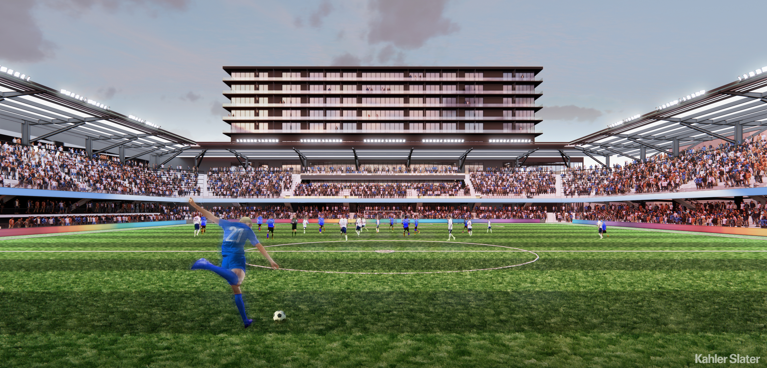
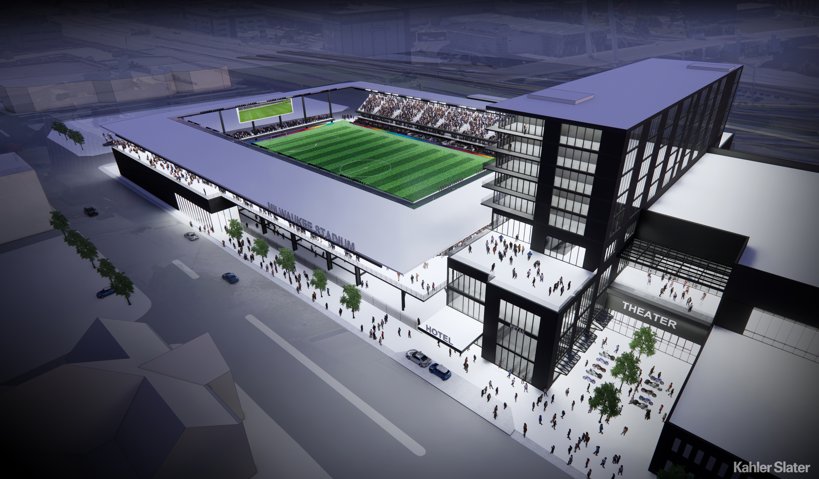
About Kacmarcik Enterprises
Kacmarcik Enterprises is a portfolio of companies in the Industrial, Human Performance & Social Impact, and Consumer sectors, all of which are committed to the collective goal of positively impacting a million lives annually.
www.kacmarcikenterprises.com
About Bear Development
With roots dating back to 1924, Kenosha-based Bear Development provides innovative solutions to complicated real estate developments. Since 1986, the company has been involved with the acquisition and development of residential, multi-family, hospitality, retail, office, and industrial projects. The firm currently owns and manages real estate in 20 states. Leveraging the most talented people available, we strive to create the highest quality real estate products designed to provide long-term value for our stakeholders. Bear is committed to creating value in the communities where we live, work and serve.
www.beardevelopment.com
About Pabst Theater Group
The Pabst Theater Group hosts close to 700 shows and events annually at its five core venues, the Pabst Theater, the Riverside Theater, Miller High Life Theatre, Turner Hall Ballroom and the Back Room @ Colectivo (in partnership with Colectivo Coffee). Additionally, the group hosts shows at the Fiserv Forum, UW-Milwaukee Panther Arena and Warner Grand Theater. The Pabst Theater Group has a financial impact on the city exceeding $250 million and spends $1.3 million in marketing annually, helping to build community, loyalty and reinforce identity and heritage for Milwaukee while employing a total of 350 full and part-time staff.
www.pabsttheatergroup.com

Media Contacts
Angela Bonovich
Kacmarcik Enterprises
bonovich@kapcoinc.com
414.207.3045

Tim Mahone
Bear Development
ttmahone@gmail.com
262.748.7418

Sara Peronto
Pabst Theater Group
speronto@ptglive.com
414.242.8149
###

